LAPORAN LKPD 5
- Topologi
[ Client / Attacker ]
│
▼
┌-------------------------------┐
│ mod_evasive │← Deteksi & blokir brute force / DoS ringan
│------------------ │
│ ModSecurity │← Filter request (SQLi, XSS, dll)
│-------------------------------│
│ Apache │
│---------------------------- │
│ Web App/PHP │

- Screenshot instalasi

- Screenshot konfigurasi
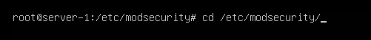
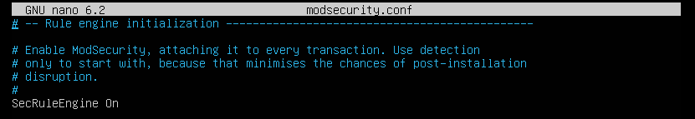
Ganti SecRuleEngine menjadi SecRuleEngine On
- Screenshot hasil pengujian
